Laboratory6-Software Construction

SEECS | NUST

Lab5

Maimoona Khalid (33422/111677) bese5B

2017

Introduction:

In this lab, we have to implement a system that gives user the 5 nearest locations based on latitude and longitude or on name. also the distance between two cities is to be found and nearest cities to a particular city is to be found.

Approach:

We begin by reading the entries from the CSV file into our application using buffer and line reader options.

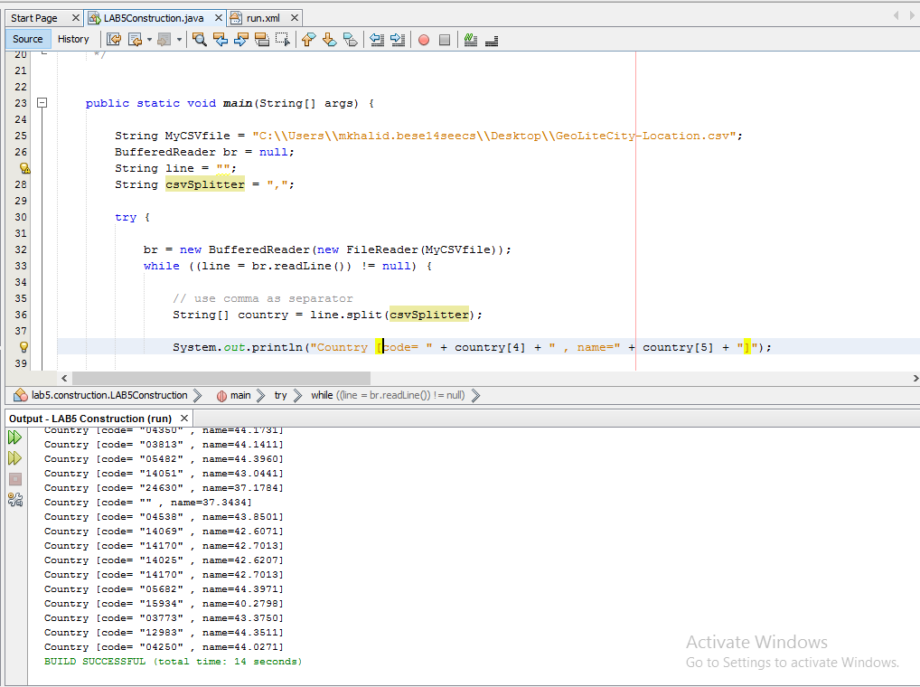

Using the hibernate platform, we connect the application with database so that the content of our .csv file get loaded in our database; for this, we first create the persistent class, then the configuration file and the xml file. We also used annottaions and a lot of other tools

How to run:

After having the database and the application connected and the .csv file made a part of the project, we run the code in Netbeans. We have used annotations and othet tools.

Githiub Link:

https://github.com/maimoona96